**Ankara University**

**COM102B – Spring 2016-17**

**PA#3: The Pong Game**

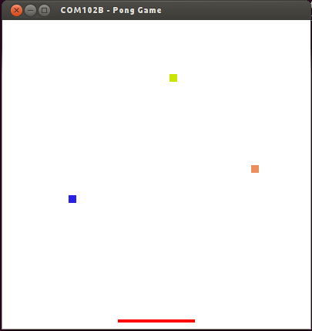

Pong game is a classical board game that includes a ball and a racket. In our case, we have multiple balls, i.e. three. The aim of the game is to keep the balls above the racket position in movement using the racket. When a ball falls down to the ground, the racket is moved through the ball position to avoid its fall on the ground. When a ball hits the racket it turns upward and keeps on its movement. When a ball hits the ground, it stops its movement; hence we lose that ball.

In the simplest form of this game, we have just modelled these movements in the file PongGame.cpp, which will be provided to you. When you run the game, you can move the racket to the right using the RIGHT_ARROW_KEY (marked with ->), and to the left using the LEFT_ARROW_KEY (marked with <-) on your keyboard. You can enlarge the balls’ size using UP_ARROW_KEY and make them smaller using DOWN_ARROW_KEY. In every run, the balls move in random directions, and initialized with random colors. When all the three balls fall to the ground, you can restart the game using ‘r’ key. Finally, you can quit the game using ‘q’ key.

Your mission is to write the class definitions for Ball, Racket and Vector2D classes that makes this game work the way we want it. The header files for this class will be provided to you. You will be writing the corresponding .CPP files (namely, Ball.cpp, Racket.cpp and Vector2D.cpp files) and submit these files in a rar package, called PA2.rar. All the member functions in these classes are defined with comments, please follow these comments while defining the member functions in cpp files.

First, you must prepare your programming environment to include necessary libraries. Please follow the instructions below to prepare your environment.

1- Install glut packages to your linux environment. You can do this using the following command from a terminal (console)

sudo apt-get install freeglut3 freeglut3-dev

2- Then, update your packages using:

sudo apt-get update

if your Ubuntu version is higher than 11.10, this update will install the true versions of the glut library.

3- Test your installations by writing this simple code in a test.cpp file:

#include <GL/glut.h>

*//Drawing funciton*

void draw(void)

{ *//Background color*

glClearColor(0,1,0,1);

glClear(GL_COLOR_BUFFER_BIT );

*//Draw order*

glFlush();

}

*//Main program*

int main(int argc, char **argv)

{

glutInit(&argc, argv);

*//Simple buffer*

glutInitDisplayMode(GLUT_SINGLE | GLUT_RGB );

glutInitWindowPosition(50,25);

glutInitWindowSize(500,250);

glutCreateWindow("Green window");

*//Call to the drawing function*

glutDisplayFunc(draw);

glutMainLoop();

return 0;

}

4- Compile test.cpp file, linking the OpenGL/Glut libraries (be careful to write the g++ command with the same order as shown below):

>g++ -o test -lGL -lglut test.cpp

5-Run your test application:

>./test

6- See a green window.

Now your working environment is ready to begin.

**Compilation Command for the Pong Game:**

>g++ -o PongGame -lGL –lglut PongMain.cpp Vector2D.cpp Ball.cpp Racket.cpp

**Run your game using:**

>./PongGame

Have fun ☺